**JAD #1 Meeting Agenda**

When & Where: February 8th, 2022 ~ 1:00pm - 2:00pm @ Zoom

Attendees: Dr. Jared Macshane, Dr. Shaunn-inn Wu, Sushi Team



____________________________________________________________________________

**Members:**

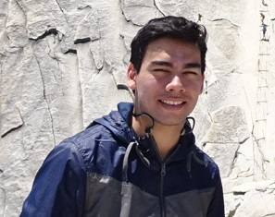

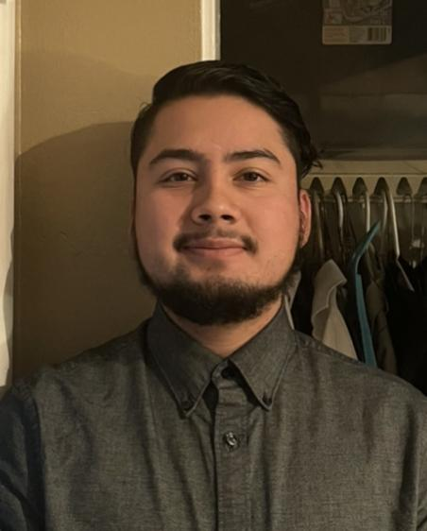

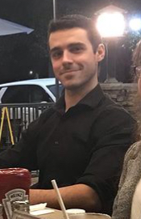

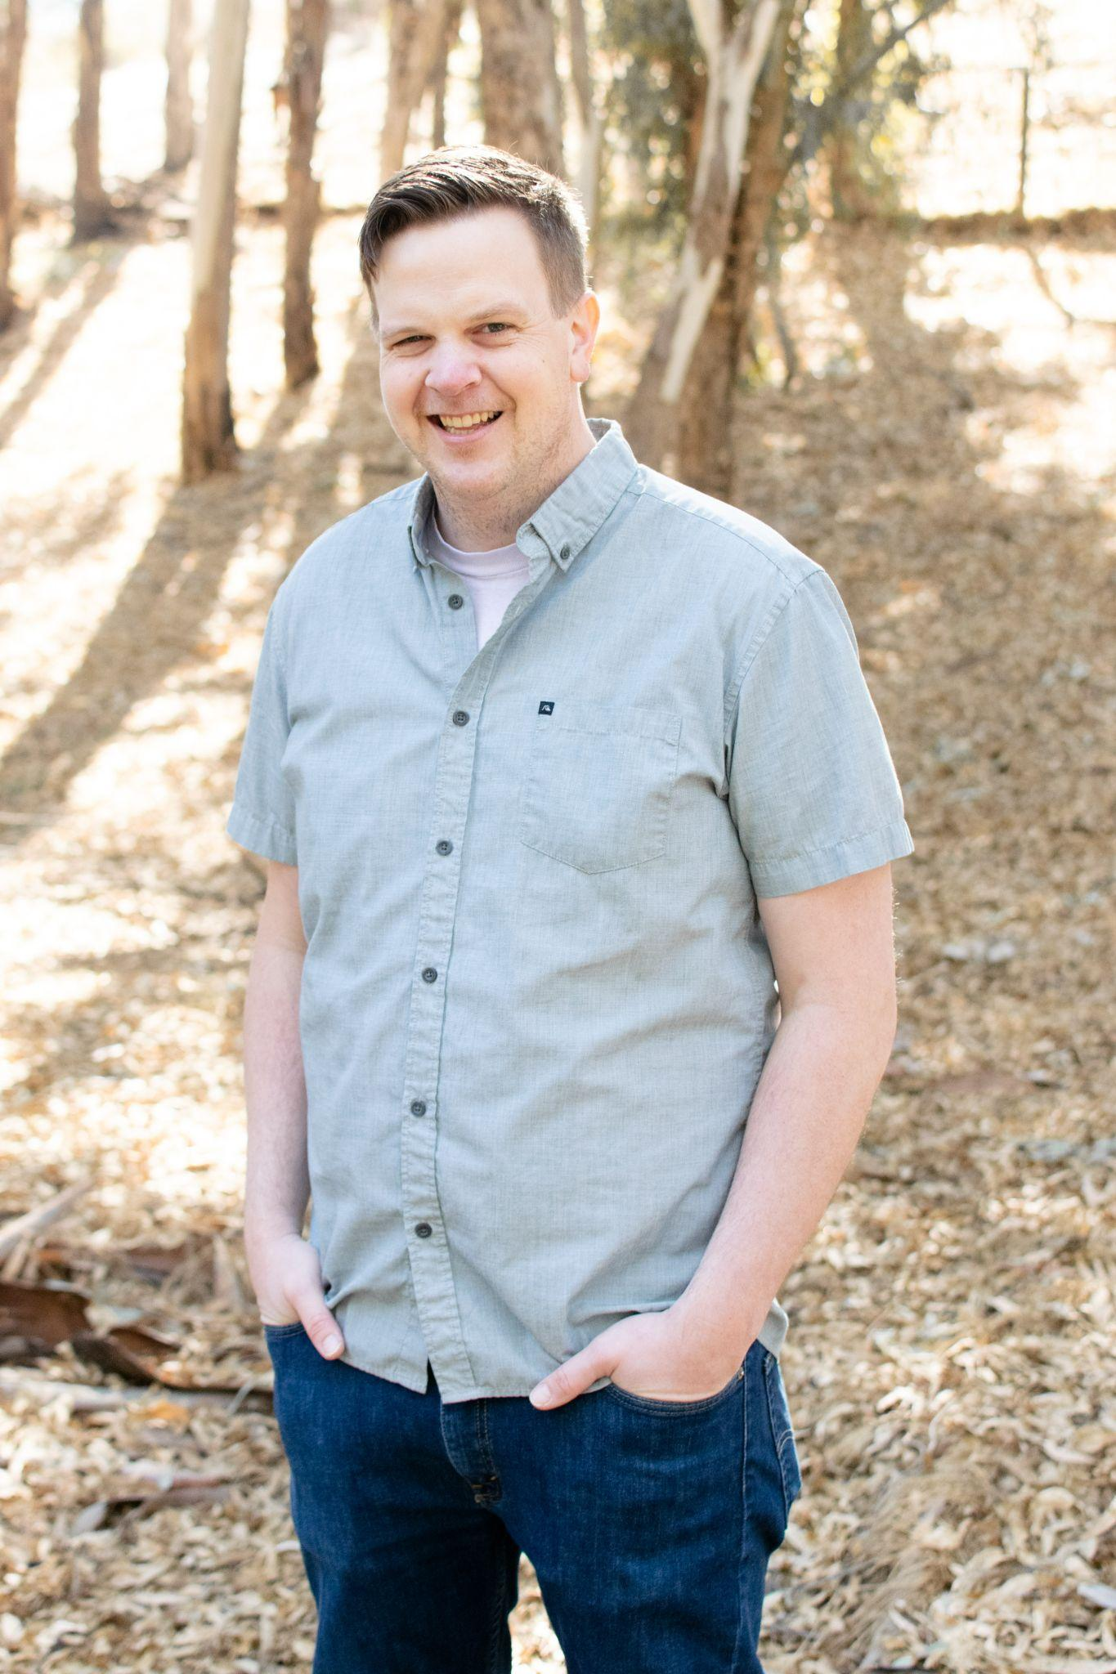

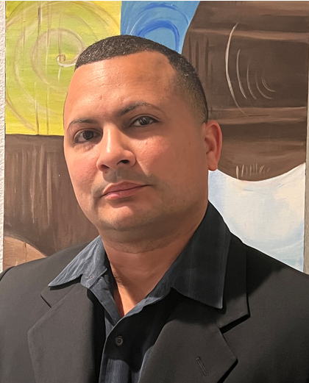

____________________________________________________________________________

**Team: Rules, Norms, Expectations:**

* On time: Team members will arrive on time. If team members are unable to arrive on time, they will make an effort to notify the team. Absences for emergencies will be excused so long as the team and Professor Wu are made aware of them.
* Respectful: Team members will act respectfully towards each other and bullying, harassment, and similar forms of disrespect are prohibited.
* Willing to learn: Each team member will be asked to learn new information and skills to complete their work on this project. This learning will both be inside and outside of the classroom.
* Open to help: If a teammate is struggling with an aspect of their work, they are expected to ask for help. Similarly when asked for help, team members are expected to assist their teammate so long as they are reasonably able.
* Communication: General team communication will be done via the group’s Discord channel.
* Quality: Team members are expected to finish their tasks at the best quality possible, satisfying the client. If work is considered poor quality by the rest of the team, it will be redone.

____________________________________________________________________________

**Goals:**

* “Build a new machine learning algorithm.” (Wesley Schultz, Feb. 1st)
* Detecting litter in images.
  + Count the amount of litter.
  + Categorize the litter (e.g. Bottle, Paper bag), alongside other metrics.
* Figure out the input/output pipeline with the retrieved image and their resulting annotations.
  + Solidified, running on a server for the UI team.
  + Formats synced up with the UI team.
* Consider utilizing open-source data sets/APIs to grab images.
  + Read the documentation from these open-source projects.
* Use a pre-trained, or create a new, model that will adapt to our specific needs.
  + Test it.
  + Grab images from the UI portion.
  + Annotate the images.
  + Train the model on those new data sets to make it more specific to our use case.

____________________________________________________________________________

**Questions:**

* **Noah (Team/Scrum Leader):**
* We will be running all this on a private server, rather than AWS, yes?
  + How shall we go about connecting to this server?
    - How frequently will we be connected to it for work, versus other platforms?
  + Any constraints/issues with using this server
    - (e.g. Speed of server, Linux/Ubuntu, Credentials)
  + Technical constraints/pricing constraints?
    - (e.g. Paid accounts for server, Paying for security to work)
* We were told by you (Jared) that we will be needing Anaconda or Miniconda to work on this project, but will we be needing a Anaconda Nucleus account as well?
  + If so, will the costs be covered by KAB, or will we have to pay for it?
* Are there other costs that will come into play?
* During the first project presentations, Dr.Schultz stated that we would be creating a new ML algorithm, yes?
  + Is that guaranteed?
  + There will be no existing infrastructure to work from?
* Getting the ML algorithm to output results is one thing, but how fast it will do so is another.
  + Do you have an idea of how long it will take the algorithm to start catching on to picking out trash in pictures? How many tests?
* **Jordan (Documentation/Training):**
* What basic metrics do we want in the formatting of our output?
  + We could break it into the super category/category system used by TACO, or we could format it into the general types of recyclables (i.e. glass, paper, plastics, etc)
  + Will it follow the section “illustration of possible detection parameters” as listed in the project proposal?
* How should features be prioritized?
  + Discerning the type of litter is a high priority feature, but discerning the brand was commented as a “nice to have” feature by Dr.Schultz.
* How to start small, then scale up?
* What are your must haves, and wants for this project?
  + Both for the ML and documentation?
* **Miguel (Programmer):**
* How will the GUI output be formatted for us to work with?
  + Is that something we will need to get in touch about with Dr.Schultz and the UI team about sooner than later? Do you have a simple output?
* What amount of interaction will we need with the UI team?
  + Like from the beginning to the end of this project?
    - Interactions every now and then? Or start off by ourselves, and then like ¾ of the way through the project, sync up with the UI team?
* We will need to set up a database on the private server, yes?
  + Or is a database already set up?
    - By the UI team?
  + Do we need to create a specific database?
    - (e.g. SQL, NoSQL)
  + How will our interactions with it be, versus that of the UI team?
* The images that we will be working will come solely from the UI team, yes?
  + Or will we need to work with images from other sources ourselves?
* **Keith (Programmer):**
* What packages will we need to install with Anaconda and how should we configure our environment?
  + Are the packages you hinted about last time available?
* How was the existing ML Algorithm handling images?
  + Does it deal with “Trash Objects” that are not currently trash?
    - (e.g. a cup in someone’s hand.)
* **Juan (Project Manager):**
* Would the primary audience be solely towards the organization Keep America Beautiful?
* How would we handle image distortion, or poor image quality - such that it can’t be determined if there’s an object in it?

____________________________________________________________________________

**Reiterate Goals with newly learned requirements.**